# CS7GV6 Computer Graphics Assignment 2

## Van Allen Bruns Jr – 19329560

YouTube: <https://youtu.be/nApxZNjOyEg>

GitHub: <https://github.com/brunsjrv/TCD-CG-Assignment2>

# Video Games and Stylized Rendering

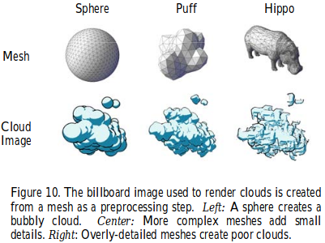For Assignment 2, my group selected video games, and more specifically stylized rendering, as our topic of exploration. For my portion of this exploration, I broke it down into five stages of implementation using the papers I selected (Mcguire & Fein, 2006) and (Reeves, 1983):

1. A particle movement simulation system
2. An object mesh representing each particle
3. Use of depth buffer
4. Outline generation
5. Cel-shading

I had proposed focusing on the first three stages, but ultimately implemented particle simulation, object mesh switching, and a basic cel-shader.

# Object Mesh

This assignment was built using the existing framework developed for Assignment 1, modified towards this topic. Since my implementation of the first assignment included the ability to load mesh objects from Blender object files, it was straightforward adding different meshes. The mesh to the left is an example of a loaded mesh. Ultimately, I selected a basic IcoSphere from Blender for better performance and due to limited implementation time for selecting the best.

# Cel-Shading

Modifying a cel-shader provided by one of my group members, Santiago, I added basic two-color cel-shading. This adds the cartoon-style rendering our group focused on.

|  |  |
| --- | --- |
|  |  |

# Particle Simulation System

The particle object framework developed is shown below. A particle manager handles the generation, removal, movement, and drawing of the particles in the system. Particles are added in conjunction with a particle portal (defining where particles enter the system) and a particle gun (defining how particles will move). Particles can be affected by multiple force fields, which can represent factors like wind affecting the movement of smoke particles.

|  |  |
| --- | --- |
|  |  |

The intention is a system generically written to allow for easy simulation of different particle environments with little implementation. The following code represents all required to simulate the environments detailed in the results section.

|  |
| --- |
|  |

# Results

Three simulations were produced using the particle system: bubbles, a cloud, and smoke (seen below). Parameters for each are also detailed below.

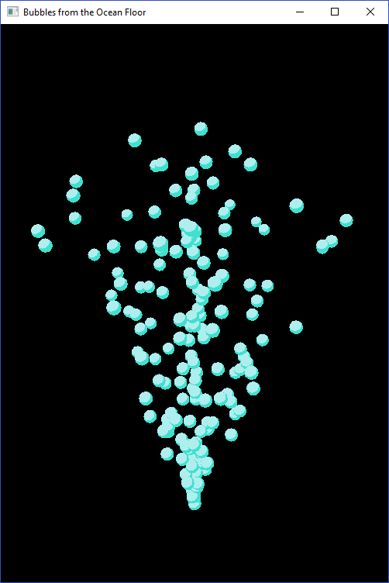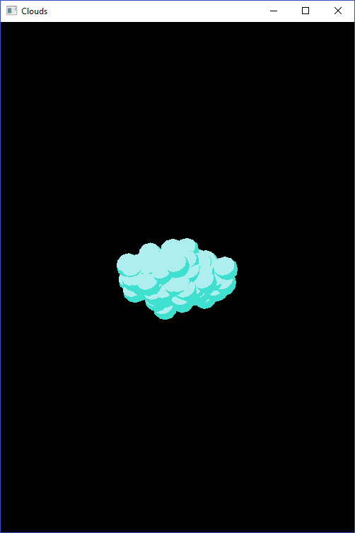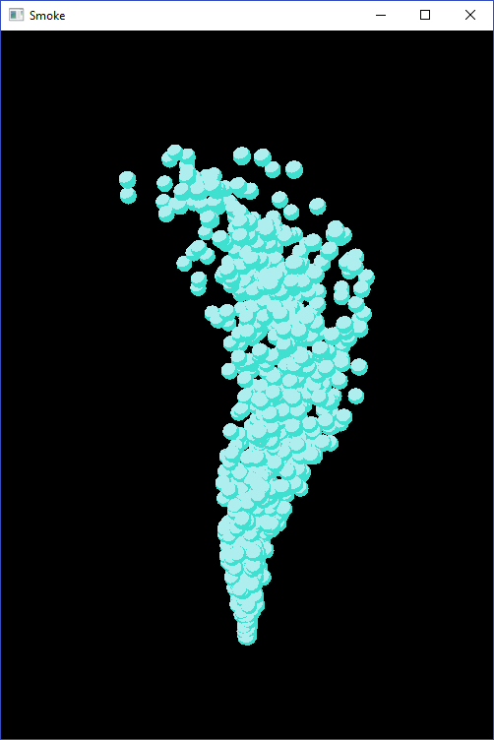

## Bubbles

Single particle portal, producing particles at half scale. Particle gun pointing upwards in a 30° cone. Manager adding 2-3 new particles every 20 cycles, with particle lifetime of 1500-2000 cycles.

## Cloud

Multiple particle portals in an 8x2x4 box, producing particles at full scale. Particle gun pointing outwards in a 360° sphere from each portal. Manager adding 6-9 new particles every 10 cycles, with particle lifetime of 1500-2000 cycles. Force field pulling particles back inwards towards the center.

## Smoke

Multiple particle portals in a 0.1x0.1 square at the base, producing particles at half scale. Particle gun pointing upwards in a 15° cone. Manager adding 10-13 new particles every 20 cycles, with particle lifetime of 1500-2000 cycles. One force field pushing particles towards the right, one force field pushing particles towards the left and upwards after the first field.

# Further Work

The original idea of using nailboards (2D objects with depth maps in a 3D world) wasn’t completely realised. Performance improvements would be achieved if all particles were instead represented with 2D objects, especially as the number of particles increase. The simulation performance could also be further expanded through knowledge in real-time rendering.

# Conclusions

This assignment gave me a more complete understanding of what it takes to implement a simulation framework. It also further defined what it means to change between different rendering styles. The group discussions and topic research helped in narrowing the scope, and practically staging the implementation.

# References

Mcguire, M., & Fein, A. (2006). Real-time rendering of cartoon smoke and clouds. *Proceedings of the 3rd international symposium on Non-photorealistic animation and rendering - NPAR 06*.

Reeves, W. T. (1983). Particle systems---a technique for modeling a class of fuzzy objects. *ACM SIGGRAPH Computer Graphics*, 359-375.